FLOOR PLANS Guide

LEVEL 1 – Brisbane Campus
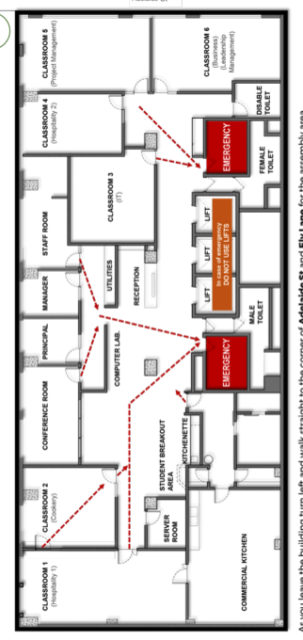

LEVEL 2 – Brisbane Campus
